Stage 1 - Java Programming
Stage 2 - Web UI Automation (Selenium) and API Automation (Rest assured)
Stage 3 - Framework Design 1 - Hybrid Framework
Stage 4 - Framework Design 2 - BDD Framework
Stage 5 - Git & Jenkins

Session - 1 PM IST to 6 PM IST
Break - 3 PM to 3:20 PM IST

Selenium - https://www.selenium.dev/
- Automates only the web application
- Open source
- Language independency - Java, C#, Python, Ruby, Javascript

Selenium - A suite of tools
- Selenium IDE
  - No programming knowledge is required
  - Record and playback feature
  - Plugin - chrome, edge, firefox
  - Use it only for simple scripting and exploratory testing.
- Selenium RC - Depreciated
  - Programming knowledge is required
  - Architecture
Source code (Java+Selenium RC) →RC Server (Turn ON/OFF) → Browser

- Selenium WebDriver (any version 3 and above)
  - Programming knowledge is required
  - Architecture
Source code (Java+Selenium WebDriver jar) → Browser

- Selenium Grid
  - If you want to scale by distributing and running tests on several machines, and managing multiple environments from a central point.
Lan network
- Hub → where the automation scripts will be present
- Node A (Linux), Node B (Windows machine)

Java Programming:
- JDK - Java Development Kit (11 and above)
  - It will also install JRE (which contains JVM)

Add below to the environment path variable
C:\Program Files\Java\JDK17\bin

- IDE for working with Java
  - IntelliJ community IDE
  - Eclipse IDE

- Architecture
Source code (.java) → Byte code (.class) → O/P

Byte code → platform independent

Complier → helps to convert source code to byte code
JVM (Java virtual machine ) → helps the Operating system to understand the bytecode.

Compile time → Source code to byte code
Run time → byte code to O/P

- IntelliJ Community - Create a project
- UpperCamelCase - MyFirstProject
lowerCamelCase - myFirstProject
- Structure
Project - UpperCamelCase
Package - lowercase (com.companyname.purpose)
Class - UpperCamelCase
Methods and variable - lowerCamelCase

- Datatypes
  - Primitive or pre-defined datatypes
  - Non-primitive or non-predefined datatypes - a collection of predefined datatypes
    - String
    - Array
      - Size is fixed
    - User-defined datatypes
- If you provide a whole number, then it will be considered as an int
If you provide a decimal value, then it will be considered as a double

- Debugging
  - Resume
  - Stop
  - Step over
  - Step into

- Conditional statements
- Iterative statements
- Methods - Building block of the program - (to reuse the logics)
  - Reusability
  - Maintenance

- Static Method - How to create and call it?
//accessmodifier static returnType methodName(arguments)

To call a static method
Classname.methodName()

- Non-static method - How to create and call it?
  - To call non- non-static method
    - Create object for that class
    - Use objref.methodName()

- Access modifier
  - Private - accessible within the class
  - Default - accessible within the package
  - Protected - accessible within the package and also through inheritance outside the package
  - Public - accessible anywhere

- Variable
  - Static variable
  - Non-static variable

- Static vs non-static
- Class
  - A class is a template or blueprint, or type from which objects are created.
- Object
  - An object is an instance of a class.
  - Every object contains its own state (non-static variable) and behaviour (non-static methods)
- Constructor - any prerequisites for the object
  - Constructor name and class name should be the same
  - It is kind of method that gets called on every object creation
  - There will always be a default constructor, which helps to load all non-static variables with default values
  - We can override the default constructor by creating it explicitly, but during object creation, we need to pass the arguments if they contain
  - Can createa constructor
    - Without argument
    - With argument
- this keyword
  - To distinguish an instance (non-static) variable from local variable
  - this keyword - points to current object
- Collections
  - Non-generic type (not recommended)
  - Generic type
    - ArrayList<>

Selenium WebDriver
- Create a java project
- Add the selenium jar
- Launch the browser
- Navigate to url
- getTitle(), getCurrentUrl(), getPageSource()
- Click, type, select
- Inspect the element → tagname, attribute, text or not
- Basic Locators
  - id
  - name
  - className
  - tagName
  - linkText
  - partialLinkText

findElement - If there are duplicate, findElement picks the first webelement

- Advance Locators
  - Xpath
  - CSS
- Dropdown
  - With Select tag
    - selectByVisibleText()
    - selectByValue()
    - selectByIndex() → index starts at 0
  - Without select tag
    - findElement and click()

- driver.get("https://www.medibuddy.in/"); - wait for page load to complete
findElement--> checks for the presence of an element in 0.5s/500ms

- Synchronization
  - Unconditional wait (from Java)
    - Thread.sleep(8000); (not recommended) → wait for 8s

  - Conditional wait (from Selenium)
    - Implicit wait
      - Default implicit wait - 0s
      - Applicable only for all findElement and findElements methods
      - Example: Implicit wait - 30s
        - If the element is not present, it will check for 30s and then throw an exception
        - If the element is present, it will move on with the operation immediately
        - Polling time - 500ms/0.5s (how freq it checks for the element)
    - Explicit wait
      - Exact condition
      - Polling time - 500ms/0.5s
WebDriverWait wait=new WebDriverWait(driver,Duration.ofSeconds(20));
wait.until(ExpectedConditions.alertIsPresent());

    - Fluent wait
      - Most advanced
      - Ignore exceptions
      - Control polling time

- Mutliple tabs/windows, alert, frame -switchTo()
- Multiple tabs
  - driver.getWindowHandles()--> get all session ids
- List vs Set
  - List can contain duplicates
  - Set cannot contain duplicates
- Close vs quit
  - close() → close the current session/current tab
  - quit() → close the current browser/all session and it will also kill the process associated to it
- To inpect → f12 or ctrl+shift+c
- Alert
  - Javascript alert
- Frame

Reference

1 GB - 1024 MB
1 MB - 1024 KB
1 KB - 1024 B
1 B - 8 bits

1 bit → 0 or 1

SOLID
- Single Responsibility Principle (SRP): A class should have only one reason to change; it should have a single job or purpose.

Java Exceptions
- java.lang.StringIndexOutOfBoundsException
- ArrayIndexOutOfBoundsException

Selenium Exception
- org.openqa.selenium.NoSuchElementException
- org.openqa.selenium.NoAlertPresentException – Add explicit wait
- org.openqa.selenium.NoSuchWindowException: no such window: target window already closed

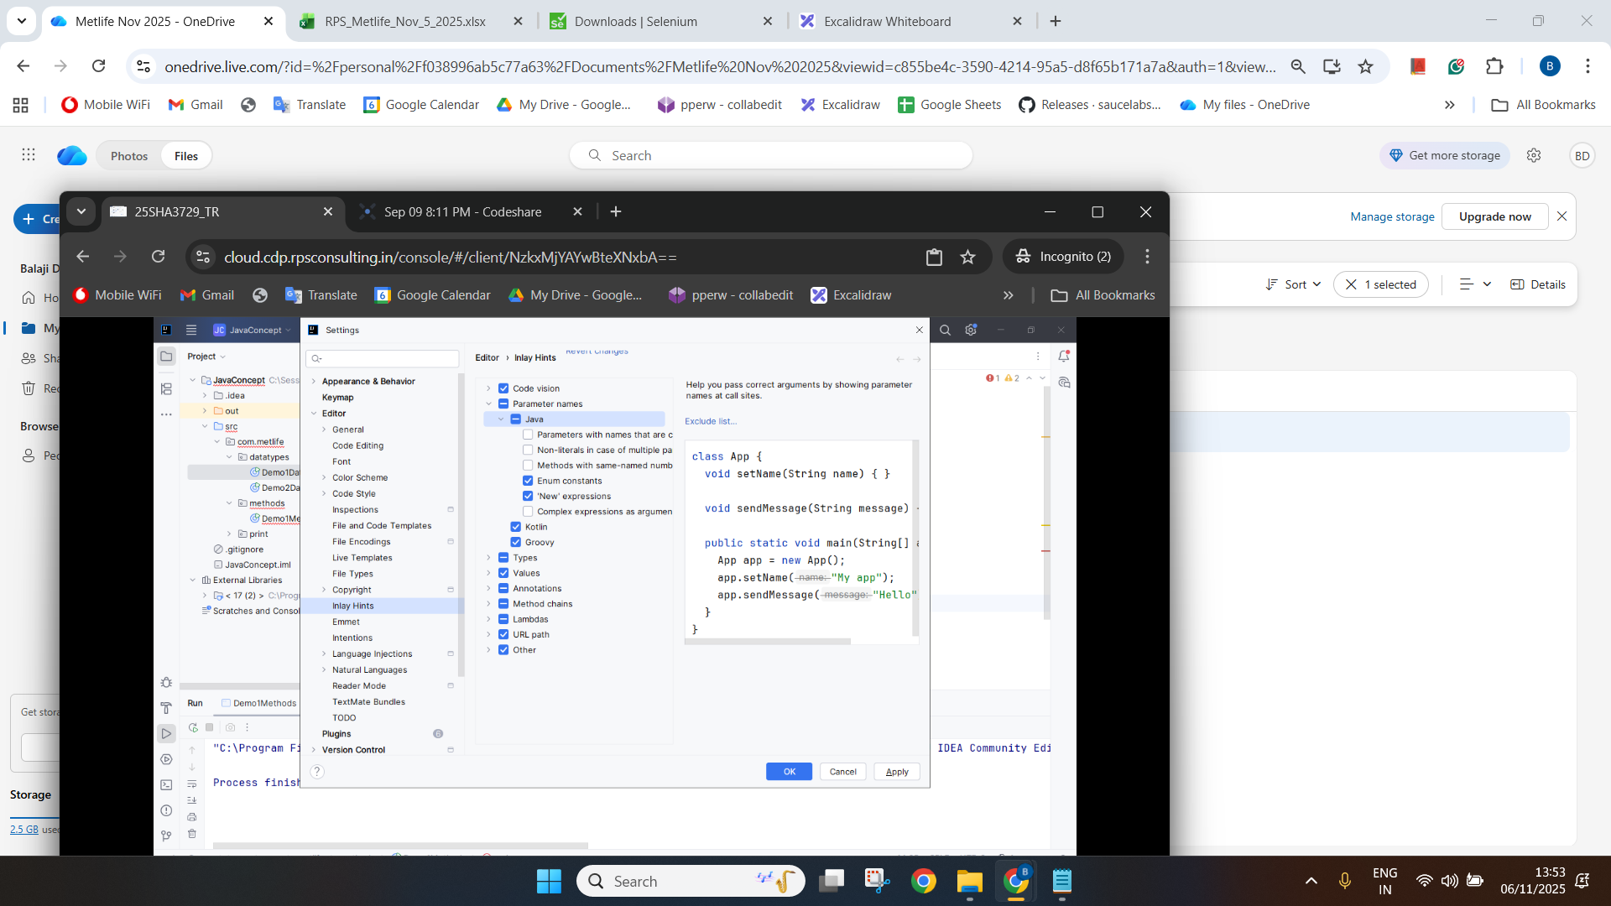

Assignment
Day 1 & 2
Task 1
1. Create Student type under student package with below details (decide between static and non-static variable)
Student - attributes/state
• studentRollno
• studentName
• studentMailid
• studentPercentage
• schoolName
• schoolAddress

2. create a method to printStudentDetails
3. Create stud_runner module under student_runner package
Create 3 different instance for storing below values
1001,"jack",jack@gmail.com,45.2, Global school, chennai
1002,"peter",peter@gmail.com,85.2, Global school, chennai
1003,"mark",mark@gmail.com,56.5, Global school, chennai

Task 2(Important)
- Navigate onto https://www.salesforce.com/in/form/signup/freetrial-sales/
- Enter first name as “John”
- Enter last name as “wick”
- Enter work email as “john@gmail.com”
- Select Job title as “IT Manager”
- Select Employees as “101-500 employees”
- Select country as “United Kingdom”
- Do not fill the phone number
- Click on check box
- Click on start my free trial
- Get the error message displayed “Enter a valid phone number”

Day 3

Task 1 (Important)
1. Navigate onto https://www.medibuddy.in/
2. Close if any popup and Click on Login
3. Click on I have Corporate Account
4. Click on Learn More
5. Click on Skip
6. Click on Login using Username & Password
7. Enter username as john
8. Enter password as john123
9. Click on show password
10. Click log in
11. Get the error message shown and print it in terminal

Task 2 (Important) - Multiple tabs
1. Navigate onto https://www.online.citibank.co.in/
2. Close if any pop up comes
3. Click on My Account
4. Click on Banking with citi
5. In new tab
6. Enter userid as john123
7. Click on signup
8. Get the error displayed for password

Task 3 (Important) - Multiple tabs
1. Navigate to https://secure1.inmotionhosting.com/index/login
2. Click on visit our support center
3. Click on “No Thanks” if any popup
4. Search for “diskspace”
5. Get the text “Search Results for: diskspace” and print it

—-------------------------
Work on anytime
Task 3
1. Create the Item class in the namespace CompanyName.Product
2. Declare public fields for ID (int), descr (String),
quantity (int), price (double).
3. Create ShoppingCart class.
4. Declare and instantiate 2 objects of type Item. Initialize only
the descr field in each, using different values for each.
5. Print the description for each item and run the code.
6. (Optional) Above the code that prints the descriptions,
assign item2 to item1. Run it again.
7. create a method in item class to print discounted price.
If qty = 2 --> print the final price by providing 10% discount of price
If qty = 3 to 5--> print the final price by providing 15% discount of price
If qty >5 --> print the final price by providing 25% discount of price

Example:
price = 100
qty = 2

if qty==2
final_price = (price – (price*10/100))*qty
print(final_price)

